**Homework OF 31-03-2025**

**Subject: CSW2 (CSE 2141)**

**Name: Arpit Kumar Mohanty**

**Registration Number: 2341013237**

**Section: 23412G1**

**Branch: CSE**

**Q1. Write Java program on Depth First Search Traversal for undirected graph  
Solution: 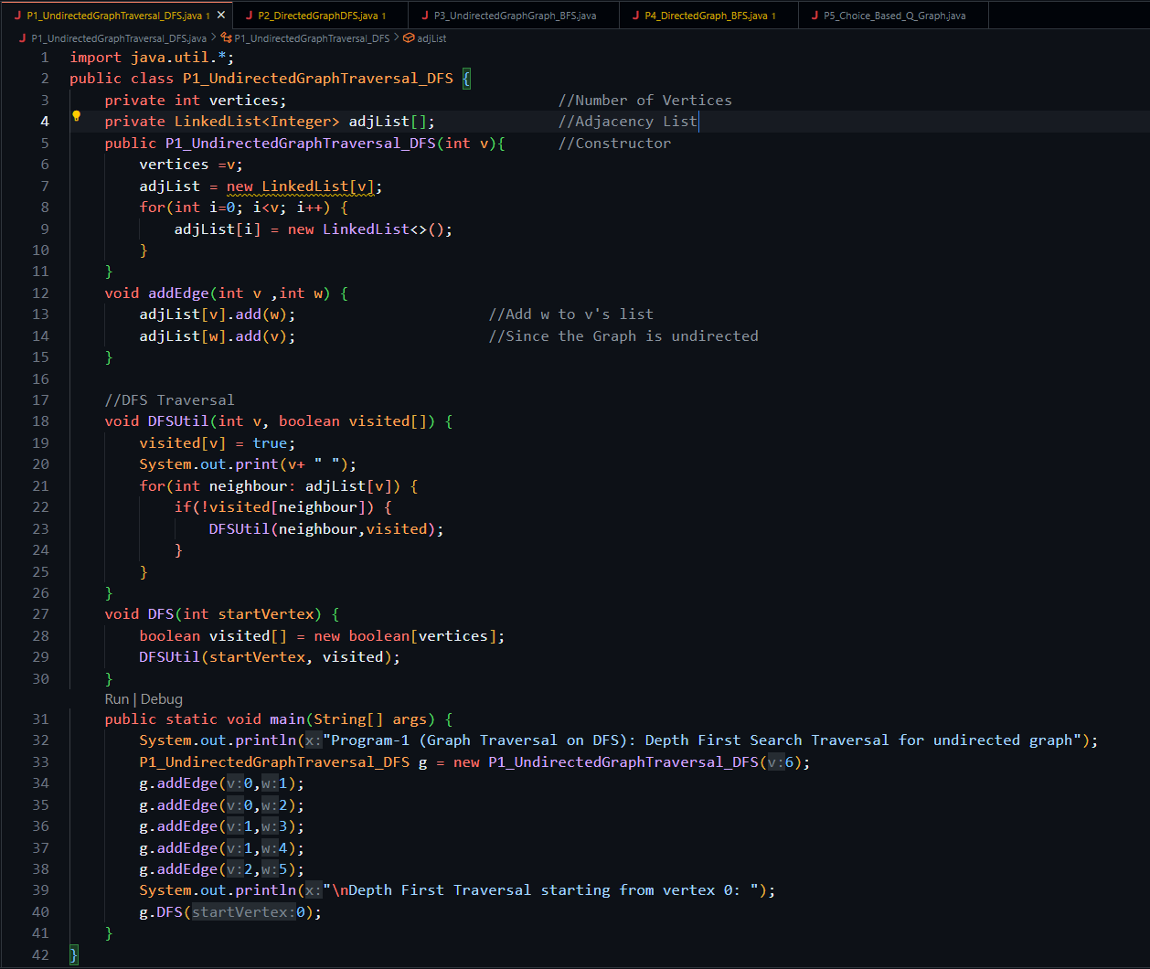 Output: 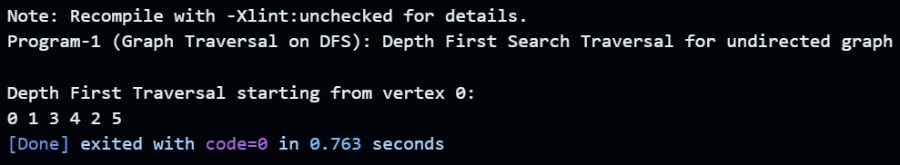  
  
Q2. Write Java program on Depth First Search Traversal for directed graph  
  
Solution: 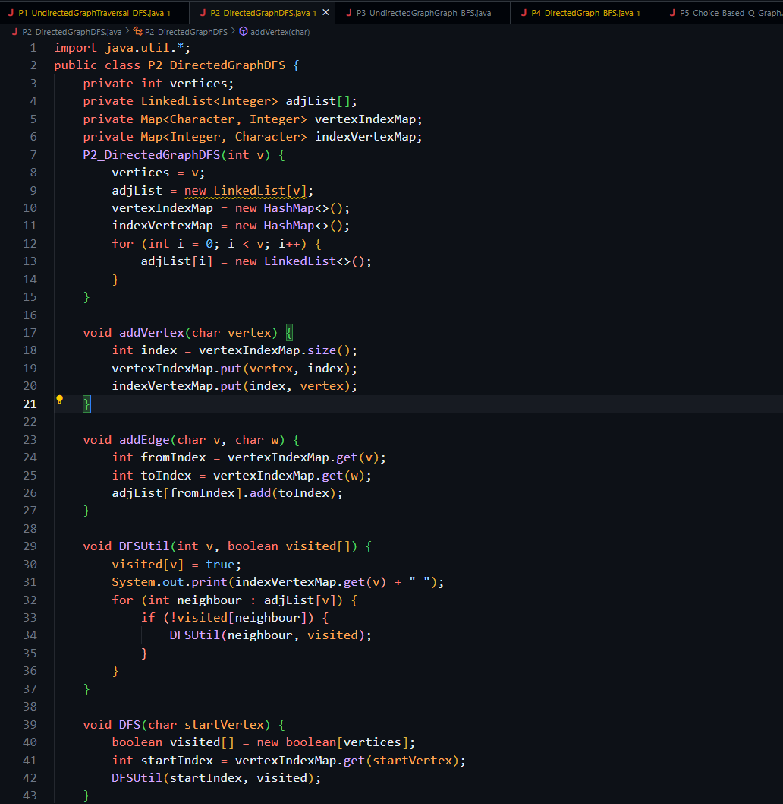  
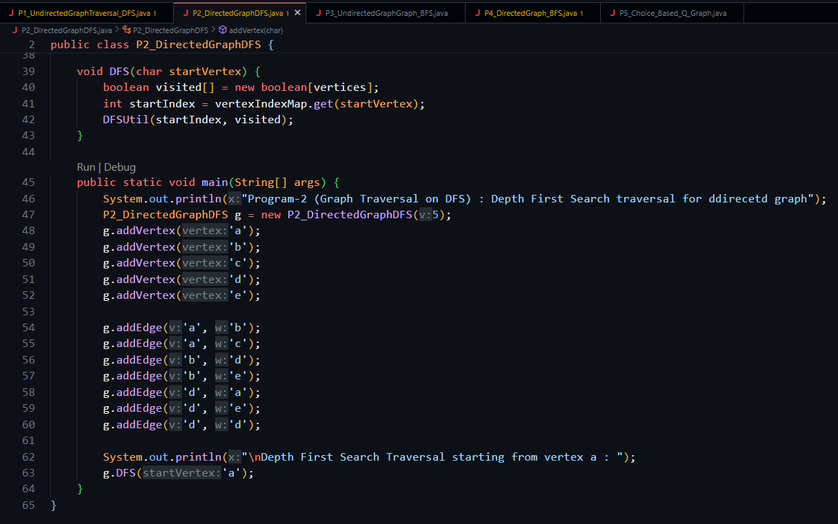  
  
Output: 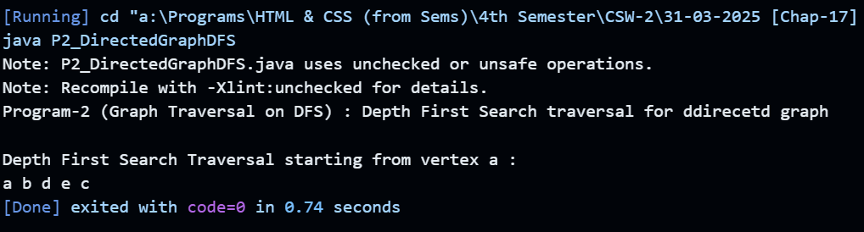  
  
Q3. Write Java program on Breadth First Search Traversal for undirected graph.  
Solution: 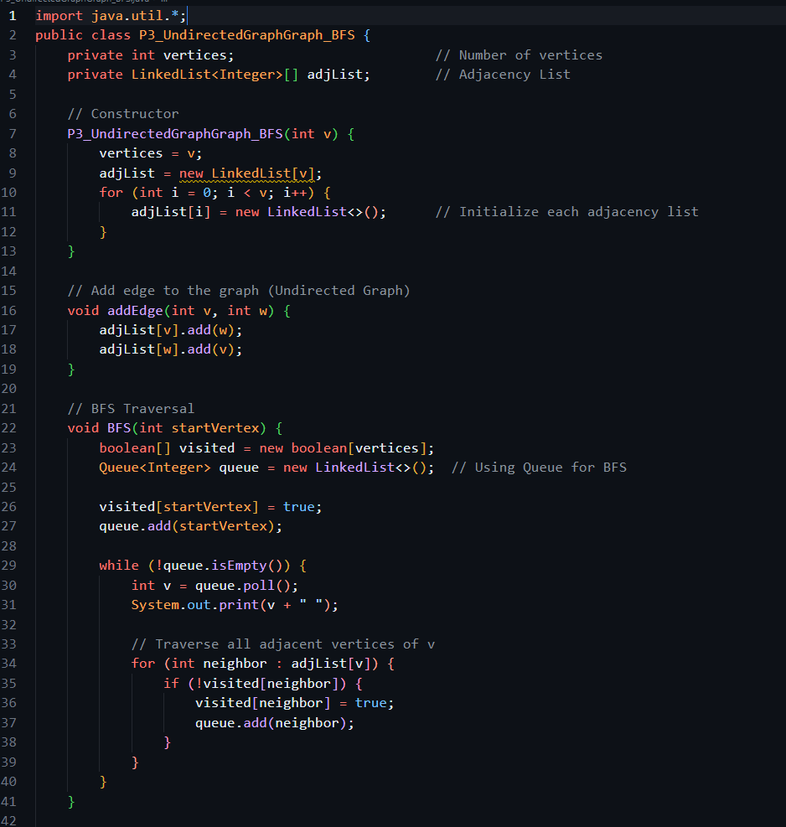  
  
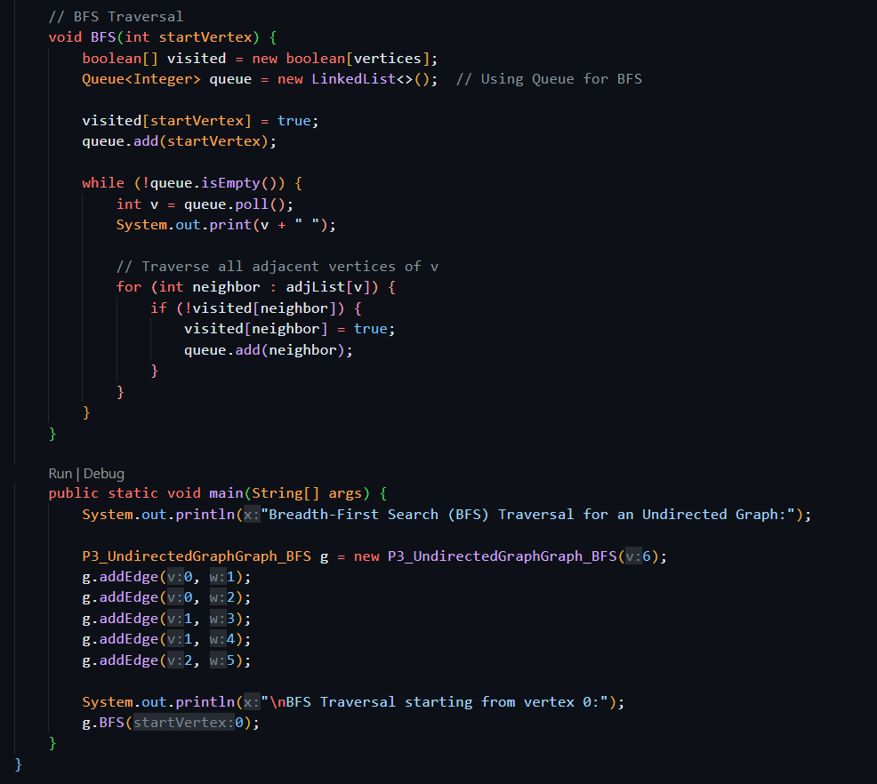  
  
Output: 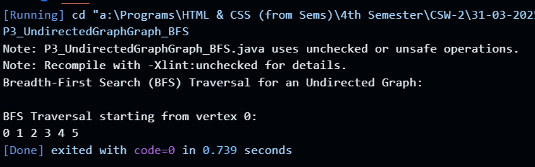  
  
Q4. Write Java program on Breadth First Search Traversal for directed graph  
  
Solution: 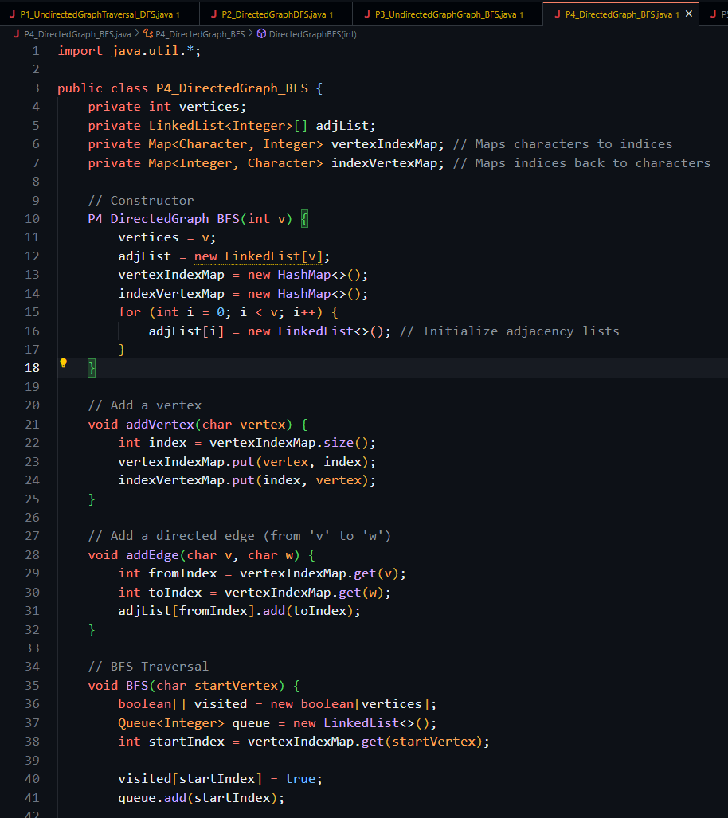  
  
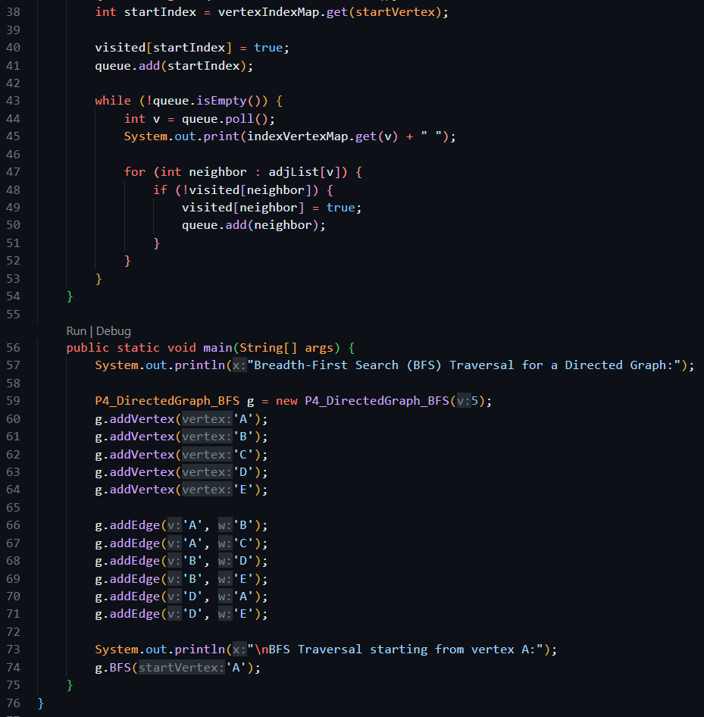  
  
Output: 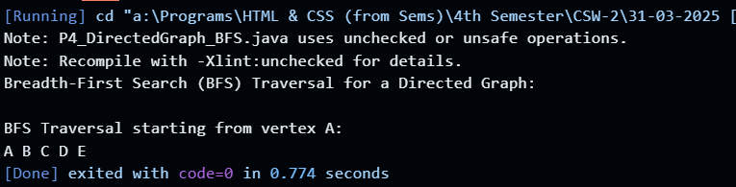  
  
Q5. Java Program on Graph Traversal using Switch case as: a) addEdge b) BFS c) DFS d) Exit default: invalid choice for the Undirected Graph. Use Scanner Class in the main function for choices in the run time and adding the edges.  
  
Solution: 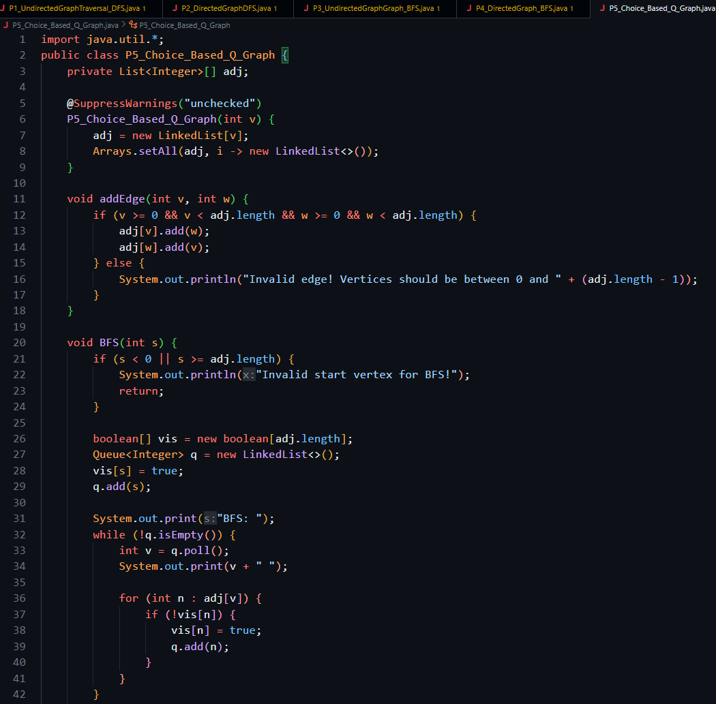  
  
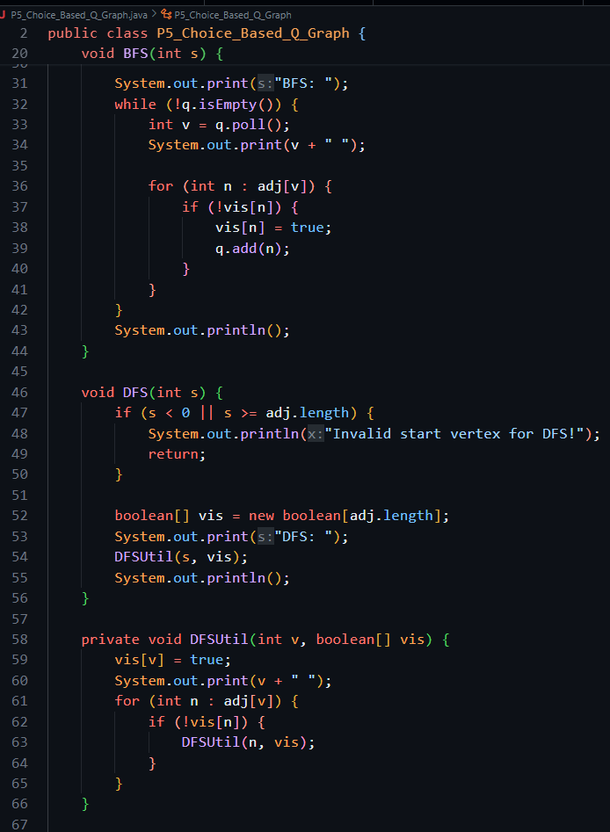  
  
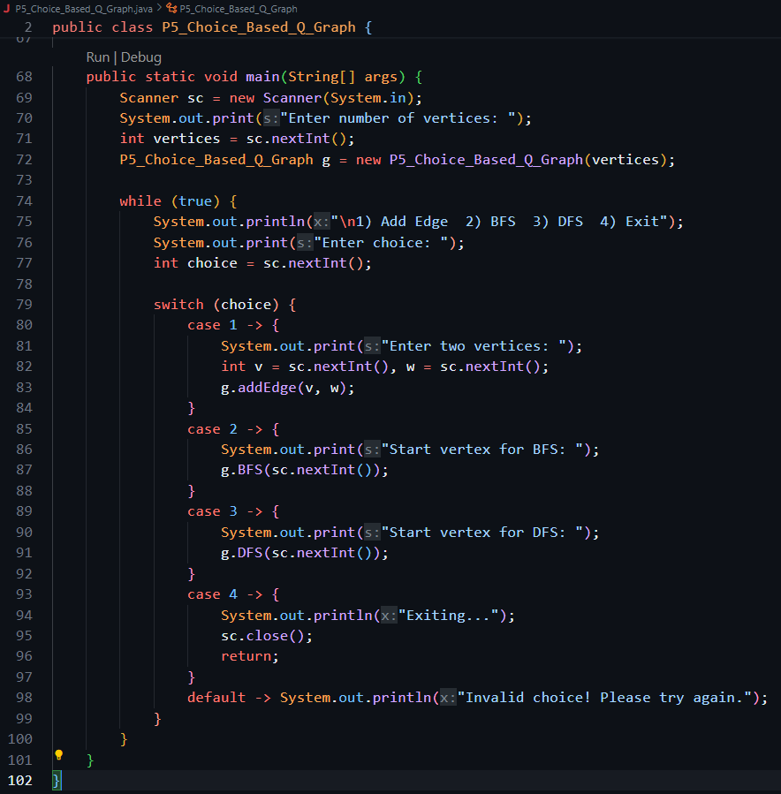  
  
Output:** 